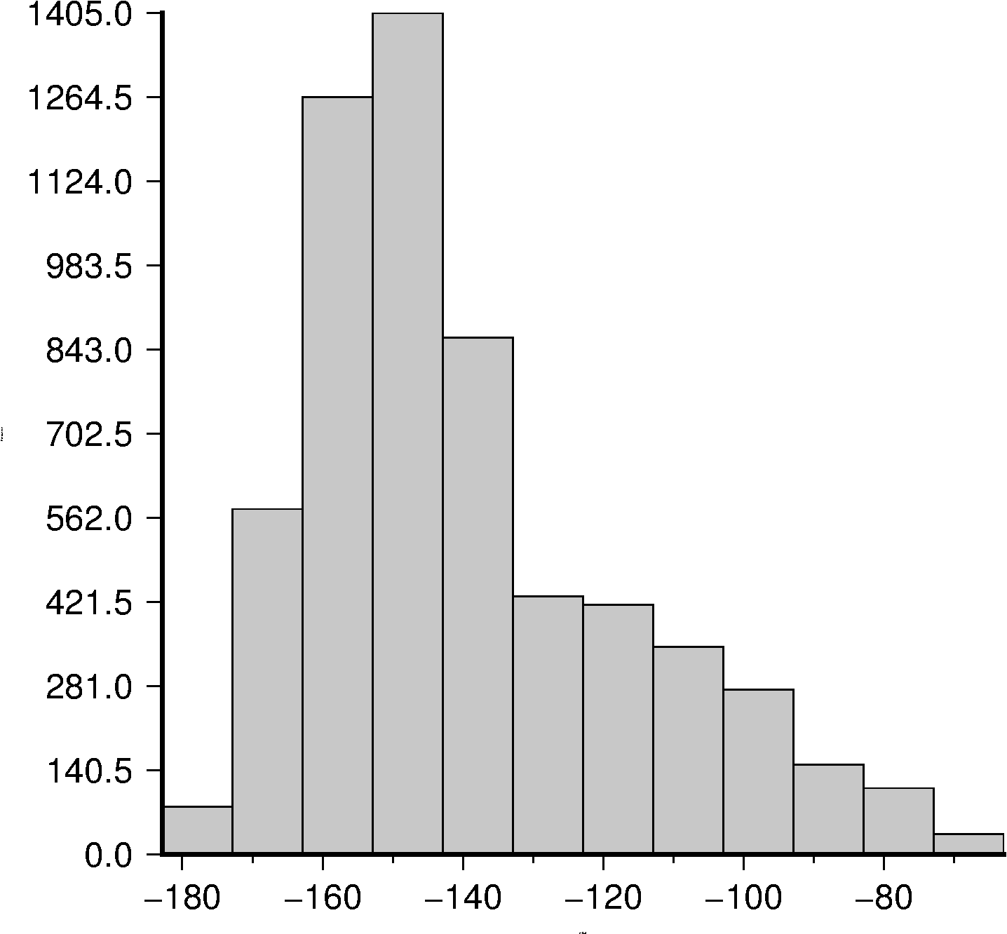

Figure 1: Histogram of gravity values for the Medicine Lake volcano and surrounding area from 41N to 43N and -123W to -121W

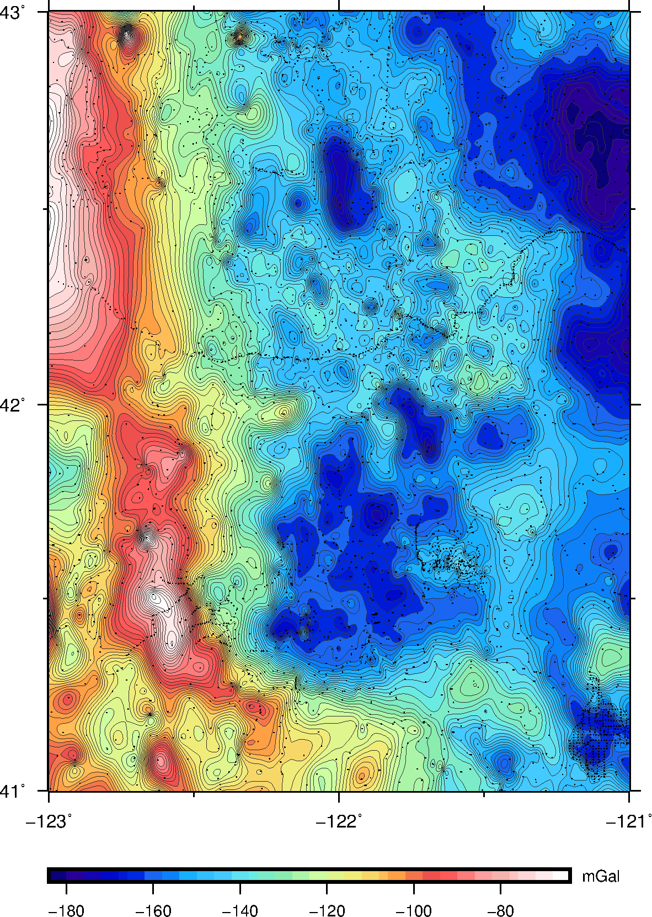

Figure 2: Gravity map for the Medicine Lake volcano and surrounding area from 41N to 43N and -123W to -121W

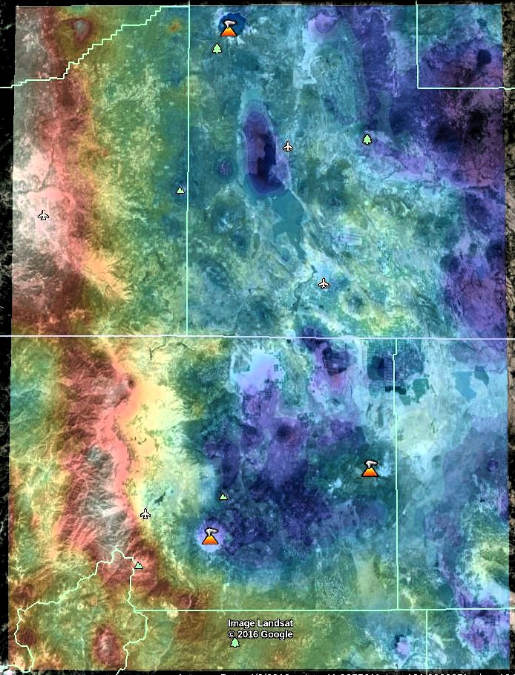

Figure 3: Gravity map overlay in Google Earth for the Medicine Lake volcano and surrounding area from 41N to 43N and -123W to -121W

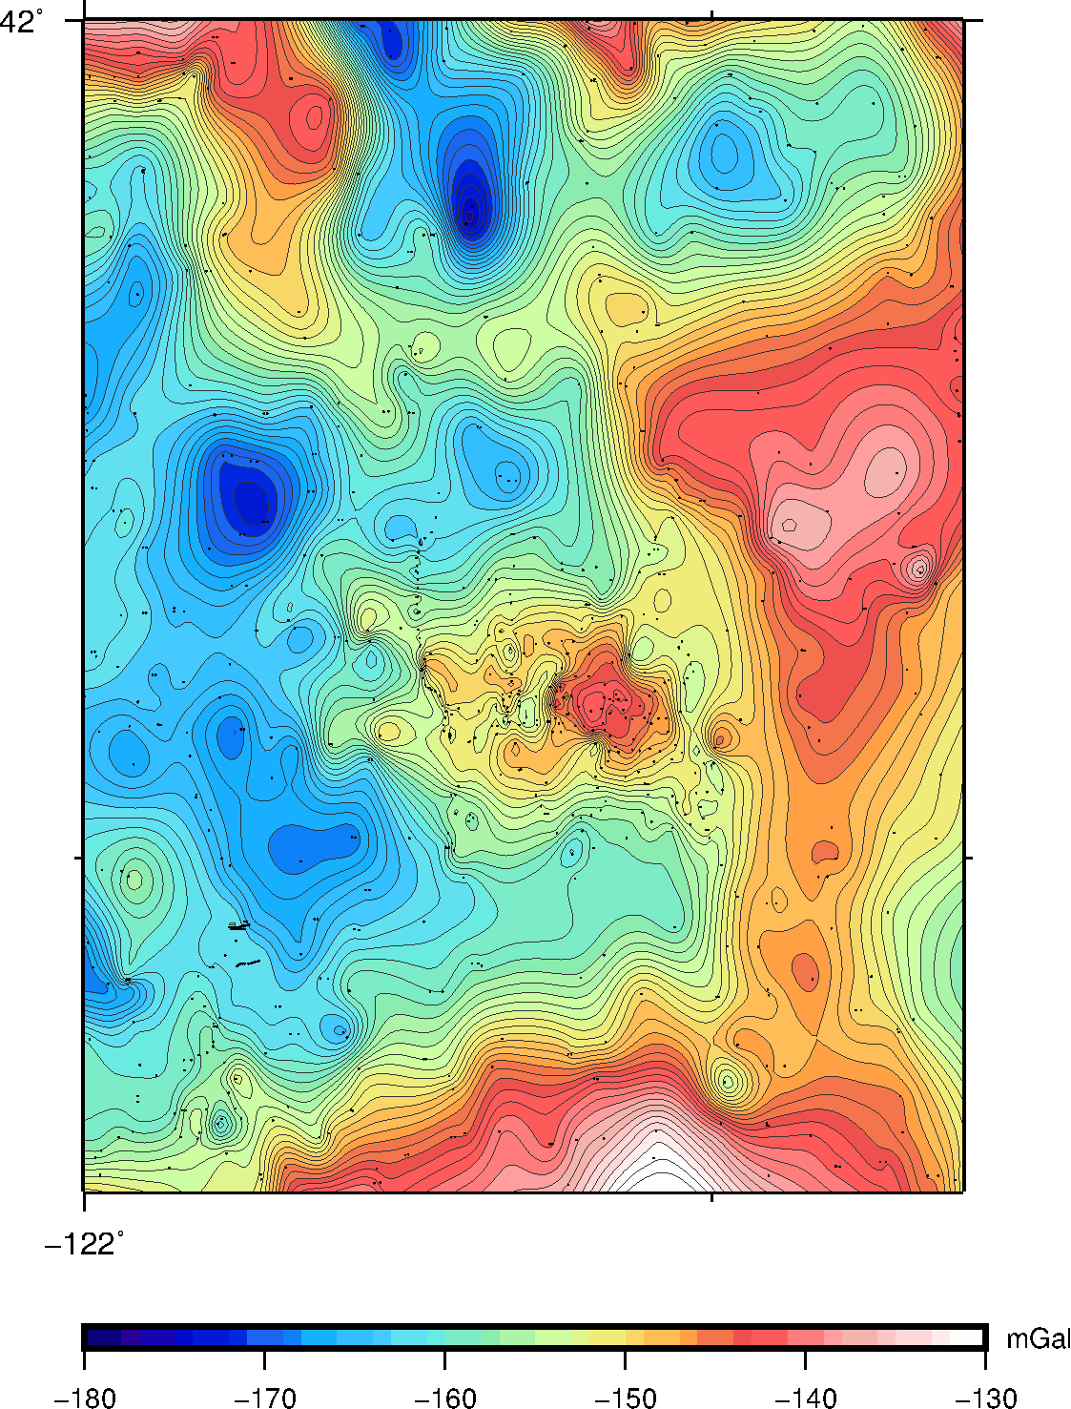

Figure 4: Zoomed in gravity map of the Medicine Lake volcano from around 41.3N to 42N and -122W to -121.3W shows closer image of anomaly seen towards the center of the area

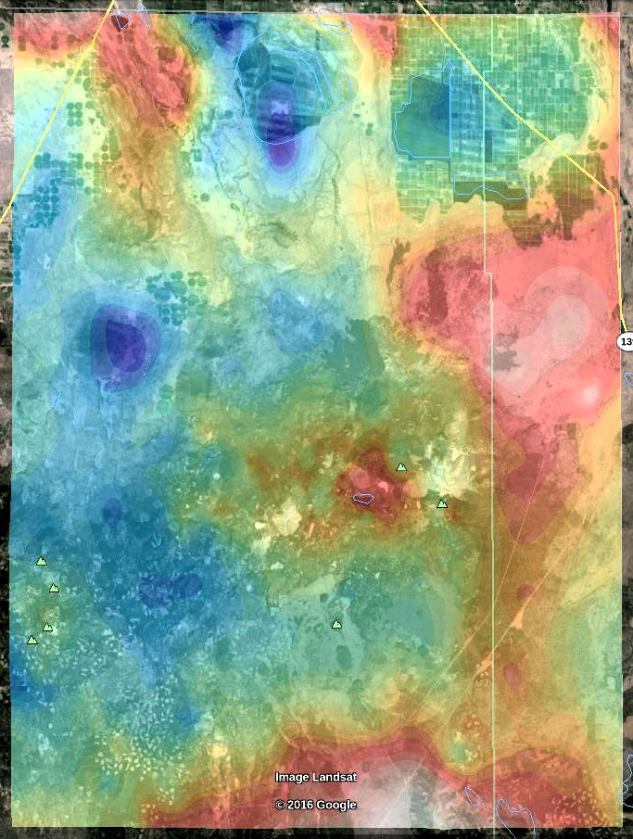

Figure 5: Zoomed in view of the Medicine Lake volcano in Google Earth with gravity map overlay from around 41.3N to 42N and -122W to -121.3W

Over the Medicine Lake volcano and surrounding area, the histogram indicates that most of the gravity data is close to or lower than the values for the anomaly. The distribution of gravity survey stations over the Medicine Lake volcano area is good for the more regional view, but some parts of the anomalous area may not have enough data. However, compared to the other caldera and volcanos visible in the area with the Google Earth overlay, the Medicine Lake volcano has a higher gravity. This could be due to an anomaly similar to the shallow intrusion discussed in Finn’s paper. Another possibility is that the anomaly could be part of the regionally higher area to the East of it that it is connected to, although it does seem to stick out from it visually. A more detailed survey of the anomaly with increased gravity and magnetic data and the addition of seismic data could refine this model.